**NSN COLLEGE OF ENGINEERING AND TECHNOLOGY**

**HAZARDOUS AREA MONITORING FOR INDUSTRIAL**

**PLANT POWERED BY IOT**

Submitted by

**TEAM LEAD: S.DINESH (920919106008)**

**TEAM MEMBERS: V.KARTHIK (920919106013)**

**A.SIVAKUMAR (920919106034)**

**M.ARUNKUMAR (920919106003)**

**K.MANOJ (920919106022)**

MENTOR NAME: G.ANAND AP/ECE (NSNCET)

In partial fulfilment of award of the degree

Of

**BACHELOR OF ENGINEERING**

**IN**

**ELECTRONICS AND COMMUNICATION**

**ENGINEERING**

**ANNA UNNIVERSITY : CHENNAI 600 025**

**1.INTRODUCTION**:

**1.1 PROJECT OVERVIEW**:

In some industrial plants, there are some areas which are to be monitored from time. Sometimes the condition become critical which may leads to loss of property and else human loss and to monitor the condition we can integrate the smart devices in the areas which are needed to be monitoring .Every device will be acting as a beacons and it is connected to temperature data along with the location of that particular area through beacons. After a plant grown into a feet it is placed into an intelligent monitoring system. Plants are monitored and controlled by mobile phone using mobile application. Errors in system are mainly due to improper monitoring of this system. So plant growth is affected. To overcome this problem the parameters are monitored by usingexceeds itslimit then thealarm is put on, simultaneously the concentration of all gases are displayed in the LCD display The proposed system is placed in an industry where the hazardous gases have to be monitored. The individual sensors are placed to read the range of gaseous concentration in ppm. Each sensor is sensitive to its own specific gas. These sensor values are read by the microcontroller, and then it is programmed to monitor the range of all gases. When the concentration of any gas**.**

0.72% to 10.74% of all kitchen accidents. The small LPG cylinder of weight 5kg in which the burner is located immediately over the cylinder without using a rubber tube is seen to be safer than the one which uses a rubber pipe as this subway has the hazards of getting cracked which in turn can make way to leakage [3]. In this research, a computer program running online was created to detect leakage locations and act as an automatic supervisor in remote areas; simple gas leak detector is a simple device that is used to detect the leakage of gas and if the gas leak occurs, an equivalent message is conveyed by the means of a buzzer and powered by Wi-Fi, it is capable to broadcast messages to the stakeholders about the LPG leak through the cloud which is based on the IoT technology; where -IoT is defined as a system that permits the devices for communicating with each other directly without human intervention [4]-. The proposed system will continuously monitor the environment for any leakage. Just in case of any leakage detection, it'll alert the user via a buzzer and by using the ESP2866 wifi microcontroller and an IOT platform ; it'll alert the user about the environmental conditions to the gas level of that location of IBM cloud (as mentioned previously) notification.

**1.2 PURPOSE:**

In every day many people are facing some industrial hazards like fire hazards, chemical exposure. It causes workers have physical and psychological problems in industrial plants. Any industry in the world. Which work make a electricity and other efficient products for peoples. So, we cannot avoid these industrial plants, but we can control the risk of power plants. Because we using automatic alarm based on IoT. Create mobile application it works detect the fire hazard and gas leak aging level in the industry. We using IoT device and web application it can protect the workers and protect the physical equipment’s of the plant. This intelligent device can help to growth of industries and improve the security protection basics of IoT make automation and give solution to the risks. Tish IOT integrated with controller and sensors for intelligent monitoring and controlling purposes like avoid hazards in industrial sides. System is made automated through IOT which improves the efficiency and reduces the efforts and it reduce hazards fire, burn, gas leakage, toxic gases, explosion, physical problems of peoples and industry**.**

**KEYWORDS: Hazardous, IBM Cloud platform, LPG, Alarm system.**

**2.LITERATURE SURVEY:**

* 1. **EXIXTING PROBLEM:**

The need to industrialize to compete with global standards is a complete requisite to realize a booming economy.However, there is no question that it has wreaked havoc on the environment caused industrial emissions of dangerous chemicals. This study aimed to create a system that will allow Industrial plants and factories to monitor the emission of the smoke stacks. But leakage can take place through pipes or regulators or knobs which may cause accidents like suffocation, uneasiness or sometimes.The existing system in gas leakage detection is done using microcontroller.This system contains only few application like gas leakage detection and producing an alarm signal whenever gas leakage is detected

* 1. **REFERENCES**

[1] S. Gruner, M. Hornacek, G. Bachinger, J. Rotroff, S. Cordes and A. Fay**,**

Cross-Industry State of the Art Analysis of Modular Automation, Automation 2020: Shaping Automation for our Future 2375, pp. 899-914 (2020). DOI:

10.51202/9783181023754-899

[2] Maar if and S. Sharifah, Compact Portable Industrial Automation Kit for Vocational School and Industrial Training, IOP Conference Series: Materials Science and Engineering 384, p.012011 (Bandung, Indonesia, 2018). DOI:10.1088/1757-899X/384/1/012011.

[3] L. Medina, R. Silva and Z. Soto, Industrial Engineering from the **Vision** of a Portable Automated Model, LACCEI 13th edition (Santo Domingo, Dominican Republic, 2015). DOI:10.18687/LACCEI2015.1.1.072

[4] Y. Feng, C. He, J. Tan, H. Zheng and Y. Gao, Assessment of the Design

Complexity of Modular Automated Assembly System, Ameches (Hanoi,

Vietnam, 2020). DOI:10.1109/ICAMechS49982.2020.9310121

[5] P. Alvarado-Velasco and V. Ayala-Ramirez, Methodology for modular automation system design, CONIELECOMP 21st edition (San Andres Cholula, Mexico, 2011).

DOI:10.1109/CONIELECOMP.2011.5749338.

[6] Harsh N. Shah, Zishan Khan, Abbas Ali Merchant, Moin mogual, Aamir

Shaikh, Priti Rane, “IOT Based Air Pollution Monitoring System”,

International Journal of Scientific & Engineering Research, Vol. 9, Issue 2,

[7]MSHA Accident/injury/illness: machinery/power Haulage data, 2001–2016.

[8] International Journal for Research in Applied Science & Engineering

Technology (IJRASET) ISSN: 2321-9653; IC Value: 45.98; SJ Impact

Factor: 7.429 Volume 9 Issue VII July 2021- Available at

[9] L. Medina, R. Silva and Z. Soto, Industrial Engineering from the Vision of a Portable Automated Model, LACCEI 13th edition (Santo Domingo, Dominican Republic, 2015). DOI:10.18687/LACCEI2015.1.1.072

**[**10] Y. Feng, C. He, J. Tan, H. Zheng and Y. Gao, Assessment of the Design Complexity of Modular Automated Assembly System.

**3.IDEATION & PROPOSED SOLUTION:**

**3.1 EMPATHY MAP CANVAS**

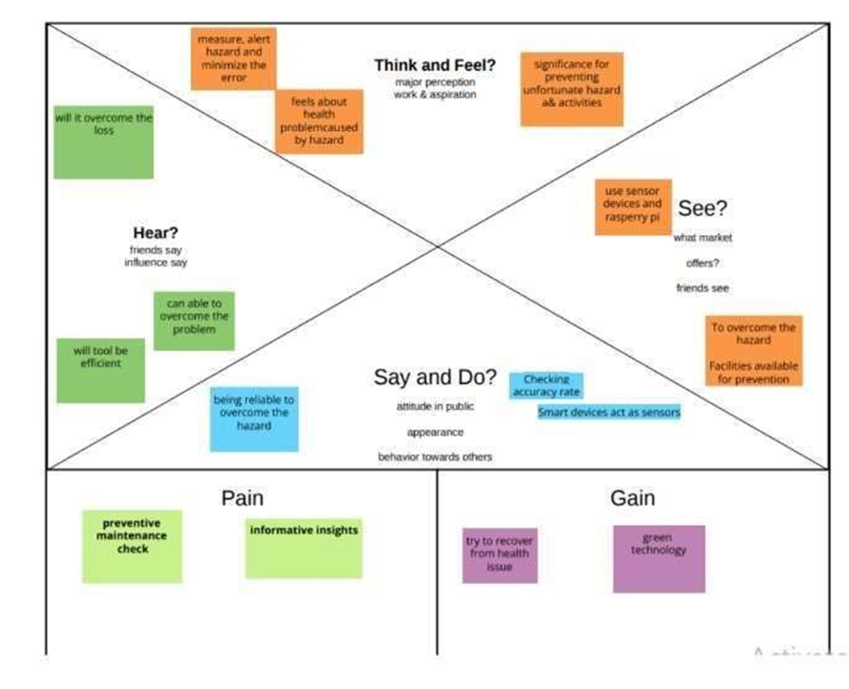

**3.2 IDEATION & BRAINSTORMING:**

Traditional gas leakage detection system have great precision.

More applicable to today's applications and smarter.

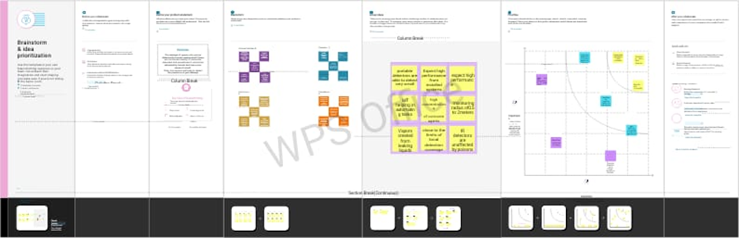

**3.3 PROPOSED SOLUTION:**

In industrial areas fire accidents can be prevented by fire detection using temperature and gas sensors. Harmful or toxic gas leakages can identified. By the use of wireless technology, information from these sensors can be broadcasted to the particular individual. Alert message are sent via an application and buzzer sound is enabled.

A versatile modular monitoring equipment for the proactive diagnosis and monitoring of a wide range of industrial equipment [2, 3] is becoming more and more useful. Automation systems have started to be modularized in order to be able monitor a wide range of equipment (such as compressors, electric motors, gas turbines, blowers etc.) A properly designed automation cabinet [4, 5] can increase productivity, lowers costs, and ensure processes reliability.

This application has a powerful impact not only on the people but also on the environment.By using this application ,individuals are alerted incase of danger or threat.Thereby environment as well as thousands of life can be saved which inturn causes contentment.

Industrial plans are the one that contain both hazardous and non-hazardous area .The monitoring of the hazardous area in industrial plants in important from time to time.If the damage that occurs in hazardous areas can result in the loss of property or lives.So monitoring for Industrial plants is a project that focuses on the necessity of the monitoring of hazardous area in industrial plants .There can be smart devices integrated at the hazardous area that can help in detecting any fishy things that can occur in the particular area.The software needs to monitor the temperature parameters of the hazardous area in industrial plants.

The uniqueness of our application we will get live updates of temperature,humidty and radiation in and around the workers environment using IoT

**3.4 PROPOSED SOLLUTION FIT**

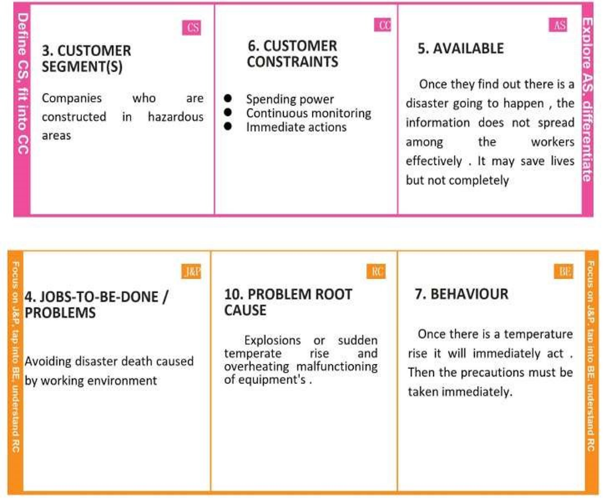

**4. REQUIREMENT ANALYSIS:**

**4.1 FUNCTIONAL REQUIREMENT:**

In infrastructure and industrial plants the rapid growth is creating environmental issues like pollution, climate change and malfunctioning. It has a great consequence for the requirement of an operationally adaptable, efficient, cheap and smart monitoring systems. For this purpose we come up with idea to use these kind of technology the Internet of Things (IoT) inform of a solution.

In this paper, we suggest wireless data gathering frameworks that enable each detector node to track the changes in the pattern of gases and to identify their role in gas leakage problem, whilst at the same time trying to minimize power consumption.

The sensor converts the physical quantity into the voltages, when concentration increases the input voltage to microcontroller through sensor is also simultaneously increases

**HARDWARE REQUIREMENTS**:

* Alarm
* Fire sensor
* Gas sensor
* Driver
* Smart wearables
* Beacons

a) Alarm

The four ways your fire alarm system works to protect your property and its occupants from the dangers of fire are by detecting fire, alerting occupants, managing risk.

b) Smart wearable’s

To inform the client around the temperature of the zone.

c) Beacons

Beacons are small, wireless ,battery operated sensors that are powered by Bluetooth low energy (BLE) technology that can detect and measure things like the temperature in a cold case, motion in a black room, the amount of items on a self, spills in the forecourt, of when a customer who signed into the store’s mobile.

d) Cloud storage

To store and get to the information. Using IBM cloud server .installed by use.

e) Temperature sensor

Temperature sensors monitor about the surrounding temperature and give the alert when the temperature level exceeds.

f) IoT

Internet of things is the method that used for the mobile access of the system where ever we live.

Here we used to monitor about the system though microcontroller unit.

j) Mobile phone

Mobile phone used to view the monitoring of hydroponic system. Which operate through the IoT. Monitoring parameters are obtained in that mobile phone itself.

**4.2 NON-FUNCTIONAL REQUIREMENTS:**

A non-functional requirement defines the quality attributes of a software system.It specifies “What should the software system do?” it places constraines on “How should the software system fulfil the functional requirements?”.In system engineering and requirements engineering a non functional requireements us a requireemnts that specifies criteria that can be used to judge the operation of a system, rather than specific behaviours. They are constrasted with non-functional requirements that define specific behaviour or functions. The pklan for implementing functional requirements is detailed in the system desigh. The plan for implementing functional requirements is detailed in the system architecture, because they are usually architecturally siginificant of non-functional requirements.

**SOFTWARE REQUIREMENTS:**

* Arduino IDE
* Microcontroller
* Power supply unit

It consists of microcontroller (PIC 16F877A), gas sensor, weight sensor (Load Cell- L6D), GSM module (SIMCOM 300), and display(s). To monitor the LPG, **an efficient and fast working microcontroller** is required. The microcontroller also controls the working of the gas sensor and load sensor output.

**5 PROJECT DESIGN:**

**5.1 DATA FLOW DIAGRAMS:**

**5.2 SOLUTION & TECHNICAL ARCHITECTURE:**

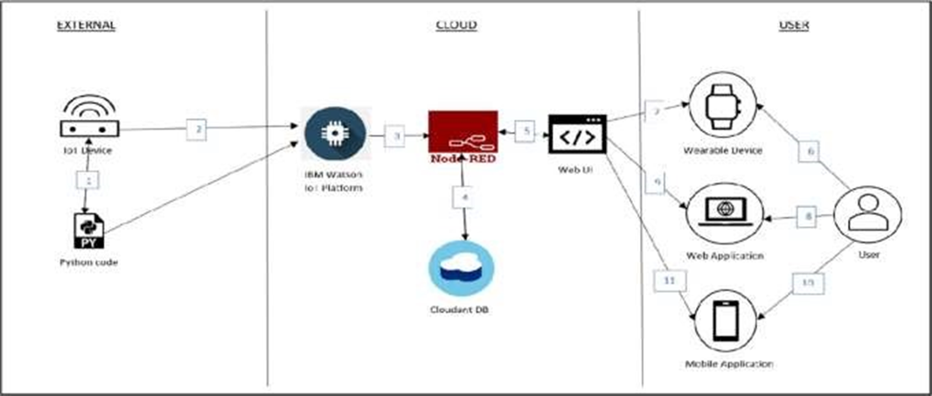

**5.3 USER STORIES:**

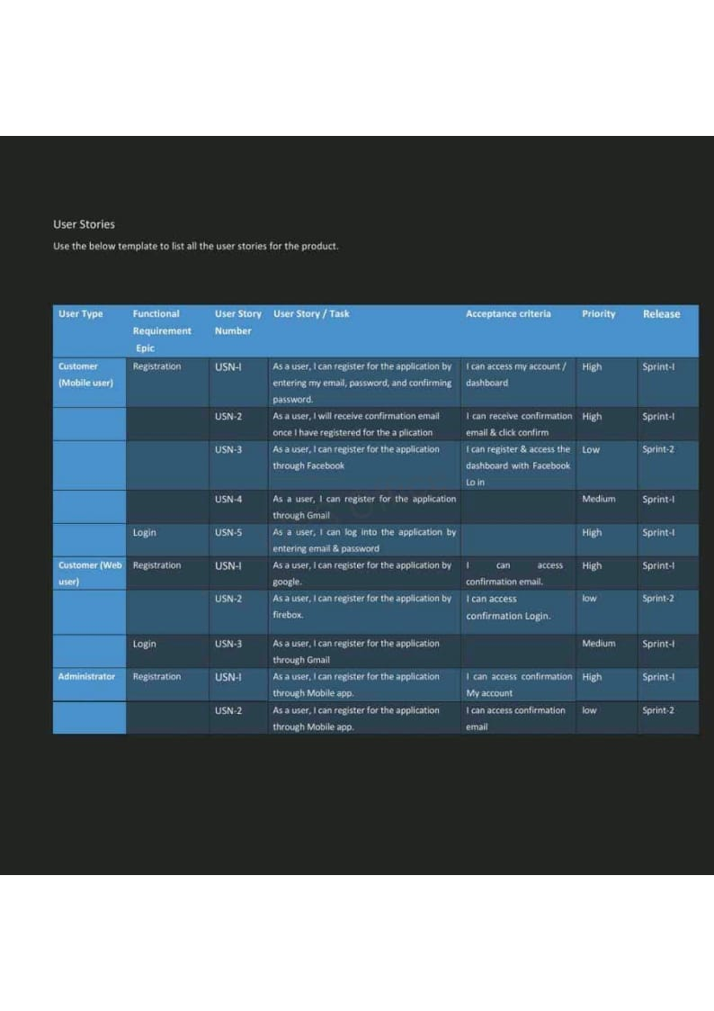

**6 PROJECT PLANNING:**

**6.1 SPRINT PLANNING & ESTIMATION:**

**6.2SPRINT DELIVERY SCHEDULE:**

**6.3 REPORT FROM JIRA:**

The circuit for an LPG leakage detector is readily available in the market, but it is extremely expensive and usually based on a [microcontroller](https://www.electronicsforu.com/microcontroller-projects-ideas) (MCU). Presented here is a low-cost circuit for an LPG detector that you can build easily.The main objective of the circuit is to detect LPG leakage anywhere.

Circuit and Working of the LPG leakage detector:

Circuit diagram of the low-cost LPG detector is shown in Fig. 2. It is built around step-down transformer X1, two rectifier diodes [1N4007](https://www.diodes.com/assets/Datasheets/ds28002.pdf) (D1 and D2), a 1000µF capacitor (C1), [7805](https://www.electronicsforu.com/resources/learn-electronics/7805-ic-voltage-regulator) voltage regulator (IC1), MQ-6 LPG gas sensor (GS1), dual comparator LM393 (IC2), darlington transistor TIP122 (T2), 12V high-gain siren/buzzer (PZ1) and a few other compon

**7 CODING & SOLUTIONING:**

**7.1 FEATURE:1**

import wiotp.sdk.device

import time import random myConfig = {

"identity": {

"orgId": "6yafic",

"typeId": "Sprint1",

"deviceId":"SprintID"

},

"auth": {

"token": "sW(iQhEK*t)4!jgrjD"

}

}

def myCommandCallback(cmd):

print("Message received from IBM IoT Platform: %s" % cmd.data['command'])

m=cmd.data['command']

client = wiotp.sdk.device.DeviceClient(config=myConfig, logHandlers=None) client.connect

while True: data=myData, temp=random.randint(0,50)

heart=random.randint(60,100)

myData={'temperature':temp, 'heartrate':heart}

client.publishEvent(eventId="status", msgFormat="json",

onPublish=None) print("Published data Successfully:

%s", myData) client.commandCallback = myCommandCallback

time.sleep(5) client.disconnect()

**7.2 FEATURE:2**

include "LiquidCrystal.h"

LiquidCrystal lcd(9,8,7,6,5,4);

int GAS_VAL = 0;

void setup()

{

pinMode(A0, INPUT); // MQ-6 A0 Pin

Serial.begin(9600);

lcd.begin(16,2);

pinMode(11,OUTPUT); // LED Green

pinMode(12,OUTPUT); // LED Red

lcd.setCursor(0,0);

lcd.print(" GAS SENSOR ");

}

void loop()

{

GAS_VAL = analogRead(A0);

Serial.println(GAS_VAL);

if (GAS_VAL > 500)

{

lcd.setCursor(0,1);

lcd.print(" LPG Detected ");

digitalWrite(11,HIGH);

digitalWrite(12,LOW);

}

else

{

lcd.setCursor(0,1);

lcd.print("LPG Not Detected ");

digitalWrite(11,LOW);

digitalWrite(12,HIGH);

}

delay(10);

}

**7.3 DATABASE SCHEME**

Today, India has around 16.64 crore active consumers of Liquefied Petroleum Gas (LPG). Around 21 million tonnes of LPG is required for consumption per annum. This deimport RPi.GPIO as GPIO

Listed below are the schemes provided for the benefit of LPG consumers.As per this scheme, BPL families can receive a new LPG connection without having to pay the security deposit for a cylinder and a pressure regulator. However, they are required to bear the following expenses,

* Installation or demonstration charges for the new connection.
* Administrative charges and cost of DGCC.
* Cost of gas stove and LPG rubber tube at the time of release of new LPG connection.
* If the stove is not procured from the LPG distributer, it needs to be inspected. These inspection charges will be borne by the customer.
* Price of LPG in the new cylinder.

All these charges should be paid to the concerned distributor.Every cylinder that is used by a consumer carries a subsidy of around Rs. 200. This amounts to a huge subsidy burden that deters the government from utilising these resources in other developmental activities. In an attempt to focus the LPG subsidy towards the needy, the government has launched the 'Opt out of subsidy' scheme. As per this scheme, the government motivates LPG consumers who can afford to pay the market price for LPG to surrender their subsidy.

Customers can opt-out from LPG subsidy through the website, www.mylpg.in or by submitting Form-5 to their distributors.

This scheme is targeted at streamlining the possession and transfer of LPG connections.

* For connection transfers, a written consent is needed from the registered customer for transfer to the person holding the equipment and SV.
* The distributor verifies the submitted documents and settles the security deposit amount between the registered customer and holder of the equipment.
* A fresh SV will be issued to the holder of the equipment.
* For people holding equipment without any connecting documents, a security deposit at the prevailing rate is charged.
* In case of death of the SV holder, the beneficiary shall be transferred the connection on submitting Death Certificate and Legal Heir Certificate/NOC.
* Transfer of LPG connection within the family is possible if the registered member provides a written consent for the same.

PSU Oil Marketing Companies act as Principals and take Insurance policies for LPG accidents including Third Party Insurance Cover. These are Public Liability Policies and are not in the name of an individual customer.

* The distributor does not collect any premium for the insurance policies from the customer.
* The claim amount is remitted through the Oil Company to the beneficiary.
* There are limits on the liability for compensation.

Under this provision, a customer can shift to an alternate distributor if he/she is dissatisfied with service. This is useful in keeping distributors competent and in providing improved service to customers.

* Customers can transfer the connection through the website, [www.mylpg.in](http://www.mylpg.in).
* The approval of the parent distributor is not needed to initiate transfer. The customer can complete required documentation at the new distributorship within the specified time.
* There shall be no transfer fee or additional security deposit for transfer of LPG connection under this scheme.
* There is a commendable electronic tracking mechanism to ensure smooth processing of the transfer request. The initial phase of the PAHAL scheme required the consumer to have  to avail LPG subsidy. This has been reviewed comprehensively and a modified scheme has been launched recently. Once a customer joins the scheme and is ready to receive subsidy in his bank account, he is said to be Cash Transfer Compliant (CTC).
* As per the modified approach, there are two methods by which LPG customers can receive subsidy.
  + Primary option - Aadhaar will remain the medium of cash transfer. The Aadhaar number is linked to the bank account and the LPG consumer number.
  + Secondary option - If the LPG consumer does not have an Aadhaar number, he can receive subsidy in his bank account irrespective of this. In this case, the consumer is required to produce his bank account information to the LPG distributor for updating the LPG database. He should also present his LPG consumer ID to his bank.
* If LPG consumers were already CTC prior to the update in PAHAL, they need not take fresh action to receive subsidy.
* As per this scheme, LPG cylinders will be sold to customers at Market Determined Price.
* Customers who join PAHAL will be provided a one-time advance, and it will remain with the customer till termination of connection. At termination, the amount will be adjusted by the distributor.

**8 TESTING:**

**8.1 TEST CASES:**

The higher the LPG gas is detected, the higher the voltage released. When the sensor output is moved The presence of gas, then Arduino will activate, and activate the buzzer and display the writing on the LCD stating the gas is high (high), which means there has been a gas leak, then the GSM SIM800L module will send a notification message to the handphone number specified in the program. However, if the sensor does not detect a leak, the sensor will not remove the output, and the sensor will continue to work until it is proven that there is an LPG gas leak. The system design in this study is described in the form of a flowchart to facilitate the reading and understanding of the system that will be made in this study. When the program is run the system will immediately detect LPG gas detected by the sensor. Then the Arduino microcontroller will read LPG gas through an LPG gas sensor. If it detects a gas leak, the red LED will light up, the buzzer will activate, then the system will send a notification message stating that there has been an LPG gas leak. If no LPG gas leak is detected, the system will continue to detect the gas level through the LPG gas sensor until it detects an LPG gas leak. System flow. The way the system works and this tool is, first when the system is turned on and this tool will immediately detect the gas content, using a sensor that is designed to be able to detect LPG gas, namely the MQ-2 gas sensor. Then each LPG gas level detected by the sensor is directly processed or converted into an analog signal. Then the analog signal will be sent directly by the MQ-2 sensor to Arduino. Because the analog signal to be sent is a number of LPG gas levels detected by the MQ-2 sensor. Then this analog signal will later become the Arduino working parameter. Does the gas level exceed the limit or not. If the level of LPG received by Arduino exceeds the predetermined limit of 5000ppm (part per million), then the Arduino will directly control the other connected ones, namely relay, buzzer, and SIM800L, by sending commands to the relay to turn on the LED (Light Emitting Diode) red which indicates danger. Then Arduino sends commands to control the buzzer to be active, to give an alarm signal as a marker in the form of sirens that there has been a leak of LPG gas that has exceeded a predetermined limit. Finally, Arduino will instruct the SIM800L module to send an SMS message to the owner, to provide information about leaked LPG gas. However, if the gas content in the form of an analog signal received by the Arduino from the MQ-2 gas sensor does not exceed the limit of 5000ppm, then Arduino will not control other components. Or in other words, the system and this tool will work normally as when the initial system was turned on, which is detecting the existing level of LPG gas. Why in this case did the author make the gas parameter limit leak at the level of 5000 ppm? Because based on the MQ-2 gas sensor technical data, the range that can be measured by the MQ-2 gas sensor against LPG type gas ranges from 200ppm to 5000ppm. Therefore, in this case, the authors set a maximum limit of the level of LPG gas leakage at 5000ppm.

**8.2 USER ACCEPTANCE TESTING:**

Power supplies for electronic devices can be broadly divided into linear and switching power supplies. The linear supply is a relatively simple design that becomes increasingly bulky and heavy for high current devices; voltage regulation in a linear supply can result in low efficiency. A switched-mode supply of the same rating as a linear supply will be smaller, is usually more efficient, but will be more complex.

**Linear Power supply:**

An AC powered linear power supply usually uses a transformer to convert the voltage from the wall outlet (mains) to a different, usually a lower voltage. If it is used to produce DC, a rectifier is used. A capacitor is used to smooth the pulsating current from the rectifier. Some small periodic deviations from smooth direct current will remain, which is known as ripple. These pulsations occur at a frequency related to the AC power frequency (for example, a multiple of 50 or 60 Hz).

The voltage produced by an unregulated power supply will vary depending on the load and on variations in the AC supply voltage. For critical electronics applications a linear regulator will be used to stabilize and adjust the voltage. This regulator will also greatly reduce the ripple and noise in the output direct current. Linear regulators often provide current limiting, protecting the power supply and attached circuit from over current.

Adjustable linear power supplies are common laboratory and service shop test equipment, allowing the output voltage to be set over a wide range. For example, a bench power supply used by circuit designers may be adjustable up to 30 volts and up to 5 amperes output. Some can be driven by an external signal, for example, for applications requiring a pulsed output.

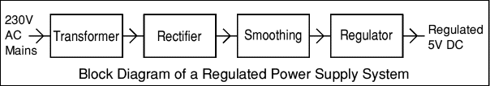

### Transformer:

### transformer symbol

The input coil is called the primary and the output coil is called the secondary. There is no electrical connection between the two coils; instead they are linked by an alternating magnetic field created in the soft-iron core of the transformer. The two lines in the middle of the circuit symbol represent the core. The ratio of the number of turns on each coil, called the turn’s ratio, determines the ratio of the voltages. A step-down transformer has a large number of turns on its primary (input) coil which is connected to the high voltage mains supply, and a small number of turns on its secondary (output) coil to give a low output voltage.

Turns ratio=Vp/Vs=Nn/Ns and Power out=Power in

Vs*Is=Vp * Ip

|  |  |  |
| --- | --- | --- |
| Vp = primary (input) voltage Np = number of turns on primary coil Ip  = primary (input) current |  | Vs = secondary (output) voltage Ns = number of turns on secondary coil Is  = secondary (output) current |

### The varying DC output is suitable for lamps, heaters and standard motors. It is not suitable for electronic circuits unless they include a smoothing capacitor. Power supplies for electronic devices can be broadly divided into linear and switching power supplies. The linear supply is a relatively simple design that becomes increasingly bulky and heavy for high current devices; voltage regulation in a linear supply can result in low efficiency. A switched-mode supply of the same rating as a linear supply will be smaller, is usually more efficient, but will be more complex.

**Linear Power supply:**

An AC powered linear power supply usually uses a transformer to convert the voltage from the wall outlet (mains) to a different, usually a lower voltage. If it is used to produce DC, a rectifier is used. A capacitor is used to smooth the pulsating current from the rectifier. Some small periodic deviations from smooth direct current will remain, which is known as ripple. These pulsations occur at a frequency related to the AC power frequency (for example, a multiple of 50 or 60 Hz).The voltage produced by an unregulated power supply will vary depending on the load and on variations in the AC supply voltage. For critical electronics applications a linear regulator will be used to stabilize and adjust the voltage. This regulator will also greatly reduce the ripple and noise in the output direct current. Linear regulators often provide current limiting, protecting the power supply and attached circuit from over current.Adjustable linear power supplies are common laboratory and service shop test equipment, allowing the output voltage to be set over a wide range. For example, a bench power supply used by circuit designers may be adjustable up to 30 volts and up to 5 amperes output. Some can be driven by an external signal, for example, for applications requiring a pulsed output.



The input coil is called the primary and the output coil is called the secondary. There is no electrical connection between the two coils; instead they are linked by an alternating magnetic field created in the soft-iron core of the transformer. The two lines in the middle of the circuit symbol represent the core. The ratio of the number of turns on each coil, called the turn’s ratio, determines the ratio of the voltages. A step-down transformer has a large number of turns on its primary (input) coil which is connected to the high voltage mains supply, and a small number of turns on its secondary (output) coil to give a low output voltage.

Turns ratio=Vp/Vs=Nn/Ns and Power out=Power in

Vs*Is=Vp * Ip

|  |  |  |
| --- | --- | --- |
| Vp = primary (input) voltage Np = number of turns on primary coil Ip  = primary (input) current |  | Vs = secondary (output) voltage Ns = number of turns on secondary coil Is  = secondary (output) current |

### AC power supply, transformer only

### DC power supply, transformer + rectifier

The varying DC output is suitable for lamps, heaters and standard motors. It is not suitable for electronic circuits unless they include a smoothing capacitor.

### Operation of a Bridge Rectifier

presence of gases is a necessity to conduct industrial operations as several pitmen had lost their lives due to lack of oxygen in the process of mining explorations. A sudden decrease in the oxygen levels can result in dizziness, brain damage, or even death among the workers working in mines or close-packed industrial premises. A gas monitoring system significantly benefits the industries by maintaining proper oxygen levels that reflect the optimal performance of your workers. This system also creates alerts in real-time about the decreasing oxygen levels, which gives enough time to take necessary measures to evacuate the facilities much before the health gets affected.

c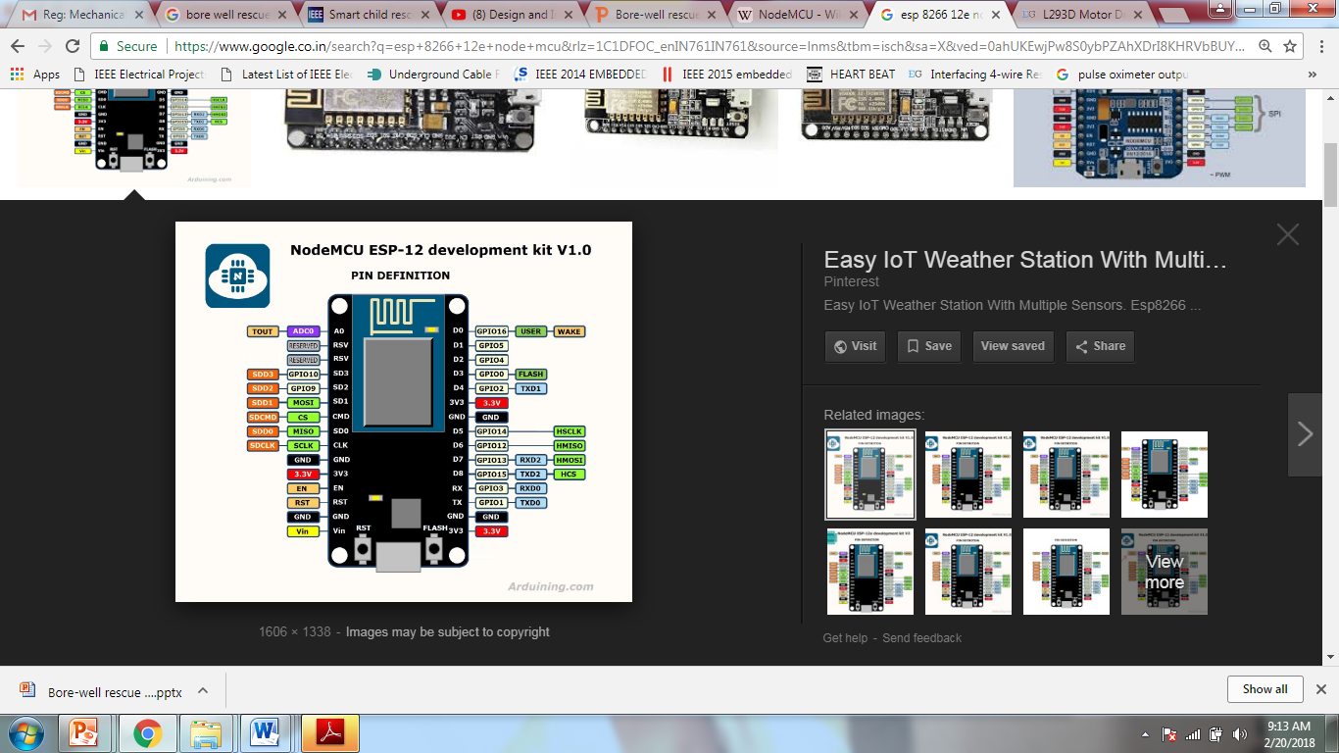

**9.RESULTS:**

**9.1 PERFORMANCE METRICS:**

The result of this project is determined by using a lighter to collect leaked gas around the gas sensor,after sensing procedure if sensor value is greater than the threshold value then ESP 8266(NODE MCU) will perform its programmed tasks : Immediately turn off the regulator knob to stop further leakage. After detecting the gas leakage, the relay will be on the Enhanst fan to prevent any further accidents. Buzzer starts beeping to alert the nearby people. The exhaust fan will fan out all enclosed gas from the environment. The wi-fi module updates the information to the cloud. The user can get to know the gas values and status of the system through the app and also control of the power supply can be done manually by the user through the app.

**10.ADVANTAGES AND DISADVANTAGES:**

**ADVANTAGES:**

The smart box has been developed as a prototype to measure the levelof air quality, dust, temperature, and humidity.

it is suitable to implement and apply in a smart city for the near future.

This will help companies in maintaining the machine Technology.and provide them emission data of gaseous elements such as carbon monoxide, particulate matter, sulfur and nitrogen dioxide that will help them in complying with the environmental standards of industrial emission.

* Get real-time alerts about the gaseous presence in the atmosphere
* Prevent fire hazards and explosions
* Supervise gas concentration levels
* Ensure worker’s health
* Real-time updates about leakages
* Cost-effective installation
* Data analytics for improved decisions
* Measure oxygen level accuracy
* Get immediate gas leak alerts

**APPLICATIONS:**

**Harmful Gas Detection:**

The sensing of toxic gases such as H2S, Methane, and CO is of great importance in any industry to avoid unwanted leakage and consequences like poisoning or explosions. The presence of these gases can be easily detected in the industrial facilities and commercial buildings with the help of IoT-powered gas monitoring solution. Moreover, a gas detector or sensor device is a crucial part to carry out safe industrial operations. The sensor-enabled solution helps prevent the high risk of gas explosions and affecting any casualties within and outside the premises.

**DISADVANTAGES:**

It gets reacted due to heating of wire. ➨It measures toxic gases in very low concentrations. ➨It has ability to detect wide range of gases. ➨It is difficult to know failure modes unless very advanced methods of monitoring are used.

* It causes suffocation, in case of leakage as it heavier than air.
* It is hazardous as it inflammable gas.
* It is consumed more as it has low energy density.
* It does not provide power to the vehicle in mountains or rough terrains.
* It is costlier than CNG.

**11.CONCLUSION:**

It is always better to have preventive measure, rather than taking actions after a disaster. Having a system to monitor the changes in the surroundings should help the owners of the industry to keep their industries safe and also keep their workers safe. Though the initial cost of installation of the device is higher, it is always better to spend on precaution, than spending on fixing any harmful situation.

**FUTURE SCOPE:**

Another major future scope could be including a Automatic Shut-off device which will turn off the gas supply whenever it will detect any gas leakage. This system can be implemented in Industries, Hotels and wherever the LPG cylinders are used.

1) Fast Speed of response.

2) Immune to catalytic poisons.

3) High Reliability & Repeatability.

4) Heated optics eliminates condensation.

5) Ability to operate in the absence of oxygen or in enriched oxygen

As detectors measure a specified gas concentration, the sensor response serves as the reference point or scale. When the sensors response surpasses a certain pre-set level, an alarm will activate to warn the user. There are various types of detectors available and the majority serves the same function: to monitor and warn of a dangerous gas level. However, when considering what type of detector to install, it is helpful to consider the different sensor technologies.

Gas Detector Technologies :- Gas detectors are categorized by the type of gas they detect: combustible or toxic. Within this broad categorization, they are further defined by the technology they use: catalytic and infrared sensors detect combustible gases and electrochemical and metal oxide semiconductor technologies generally detect toxic gases.

Measurement of Combustible Gases :-

Catalytic sensors represent a large number of gas detector devices that are manufactured today. This technology is used to detect combustible gases such as hydrocarbon, and works via catalytic oxidation. The sensors of this type of detector are typically constructed from a platinum treated wire coil. As a combustible gas comes into contact with the catalytic surface, it is oxidized and the wiring resistance is changed by heat that is released. A bridge circuit is typically used to indicate the resistance change.

Infrared sensors or IR detectors work via a system of transmitters and receivers to detect combustible gases, specifically hydrocarbon vapors. Typically, the transmitters are light sources and receivers are light detectors. If a gas is present in the optical path, it will interfere with the power of the light transmission between the transmitter and receiver. The altered state of light determines if and what type of gas is present.

Common Gas Detector Applications

Although detectors are an essential application for home and commercial safety, they are also employed in numerous industrial industries. Gas detectors are used in welding shops to detect combustibles and toxics and in nuclear plants, to detect combustibles. They are also commonly used to detect hazardous vapours in wastewater treatment plants.

Gas detectors are very efficient in confined spaces where there is no continuous employee occupancy. Such spaces include tanks, pits, vessels and storage bins. Detectors may also be placed at a site to detect toxins prior to occupant entry.

The chemical industry is a major player in the global economy.

Leak Detection:

Leaks are an ever-present hazard even in the best run chemical plants. Depending on the severity of the leak and the gas involved, the effects can potentially be very serious both within and without the perimeter of the plant. An explosion or fire will damage plant and put workers at risk, while toxic gases can spread rapidly, also putting the public at risk. Even a minor small leak has an economic impact on the plant's profitability as material is being wasted and the fault has to be rectified. To monitor for leaks, fixed gas detectors are integrated into the plant at key weak points such as valves, joints and pumps. The sensors used will obviously depend on the nature of the gas to be detected. For flammable gases, pellistors are widely used. This sensor works by burning the target gas; the heat generated producing a change in the resistance of the detecting element of the sensor proportional to the gas concentration. To detect hydrocarbons, NDIR sensors are widely used. Ultrasonic gas leak detectors measure the ultrasonic sound level, typically between 25 kHz to 10 MHz frequencies. Ultrasonic gas detectors are mainly used for outdoor environments where weather conditions can easily dissipate escaping gas before allowing it to reach gas leak detectors that require contact with the gas in order to detect it. These detectors are most useful in facilities with a lot of outdoor pipeline.

**13 APPENDIX:**

Fire detection using temperature and gas sensors. Harmful or toxic gas leakages can identified . By the use of wireless technology, (5) information from these sensors can be broadcasted to the particular individual. Alert message are sent via an application and buzzer sound is enabled. The uniqueness of our application we will get live updates of temperature, humidity and radiation in and around the workers environment using IoT. This application has a powerful impact not only on the people but also on the environment.by using this application ,(2)individuals are alerted incase of danger or threat. there by environment as well as thousands of life can be saved which causes contentment.